

GREN BARTLEY

Gren Bartley is a UK singer-songwriter and guitarist working somewhere between cinematic folk, intimate acoustic songwriting and finely detailed guitar work. Across a run of acclaimed releases, he has built a reputation for records that are atmospheric, melodic and unmistakably his own.

His 2015 album Magnificent Creatures, produced by Gavin Monaghan, received outstanding reviews and helped take his music to festivals and venues across the UK and Europe. In 2019 he released Quiet, a more stripped-back collection drawing on folk, world music and bottleneck slide guitar, which earned further critical praise.

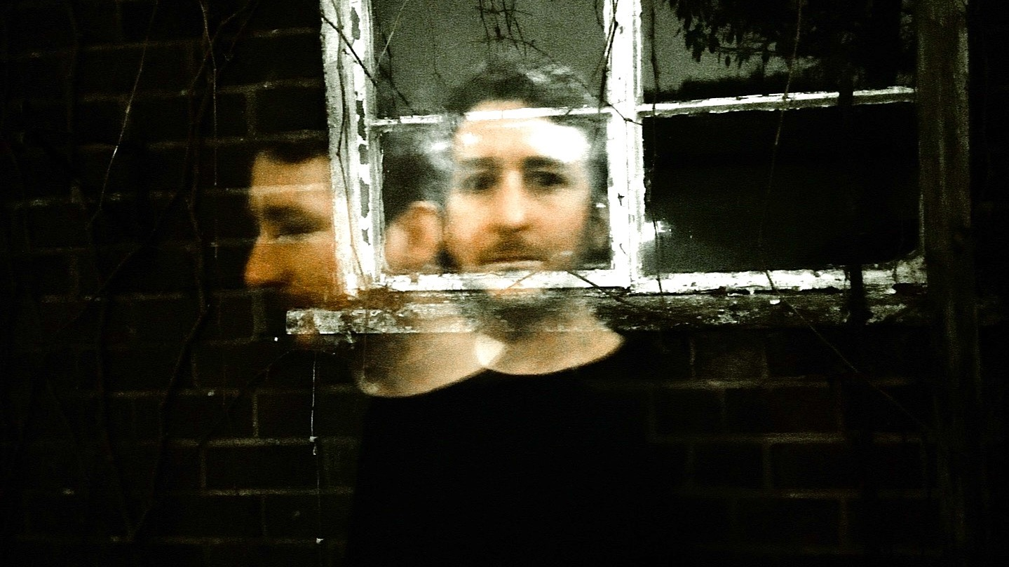
His new album Sunsets, Circles and Waves was released in May 2026. Recorded live in complete takes with no overdubs, it captures the warmth and intimacy of a real performance while deepening the reflective, immersive quality that runs through his work.

Gren Bartley writes songs with the instinct of a folk artist and the detail of a craftsman. Drawing on older traditions without sounding trapped by them, he has developed a style that feels warm, immersive and entirely his own.

“He’s invented his own kind of music… and everything about it is class”
BBC Radio

“Constantly outstanding songwriting”
fRoots

“Astounding”
KLOF Magazine

“This chap has a gift”
Living Tradition Magazine
​
“Will be heard more often once people realise just how good he is”
Northern Sky

grenbartley.com
facebook.com/grenbartley
instagram.com/grenbartley
youtube.com/grenbartley
grenbartley.bandcamp.com

For further information, please contact Ant Miles at Fancourt Music
07837 881941 | ant.miles@fancourtmusic.com | fancourtmusic.com/grenbartley

